Paul Witt

Here are the steps I took. I think my issue is with the assignment operator. I need to sum the

What’s Up Method

Created a string array

Created a for loop that randomizes the array index

Created another for loop to output each task and show the number of occurrences.

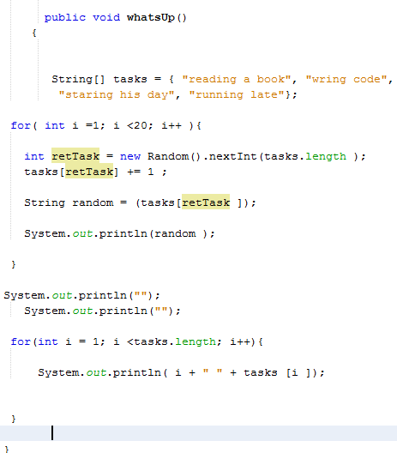

Below are the outputs for each loop. The “1” next to the task is the number of times it returned from the loop. The first column shows the numbers adding up as the loop goes through. The second column shows the total number of times each instance of the array was returned randomly.

|  |  |
| --- | --- |
| Random out put | Each array element with number of occurances |
| getting ready to go home1  doing math1  staring his day1  sleeping1  staring his day11  sleeping11  sleeping111  running late1  wring code1  staring his day111  doing math11  sleeping1111  talking with his friends1  staring his day1111  wring code11  talking with his friends11  staring his day11111  reading a book1  talking with his friends111 | 1 wring code11  2 giving a speech  3 talking with his friends111  4 doing math11  5 doing science  6 sleeping1111  7 getting ready to go home1  8 staring his day11111  9 running late1 |